Nornu Ninayor
IT3883/W02
Final Exam
05/03/25

Final Exam Documentation

Explanation of code: This is a code that will allow users to turn a sentence into numerical value. It calculates whatever is written that involves coins only. Not dollars, only coins. So, users will write either several quarters, nickels, dimes, and pennies and the code will calculate that. The code can bypass the plural and singular form of the coin and still calculate it. So, whether it says penny or pennies the code should still account for it.

Sprint1 design:

Start:

#IT3883/W02
#Nornu Ninayor
#Final Exam
#05/03/25
#It also includes error handling to prevent crashes from invalid inputs.
#Resources used W3chool,youtube,& google, lecture notes

#Convert the words into numbers
coin_value = { #naming the value, since we are taking about money I put coins.
"penny":0.01, #unit decides to place them from smallest to greatest because that’s what made sense
"nickle":0.05,
"dime":.10,
"quarter":.25
}
def convert_words_into_value(sentence):# this lines makes sure that sentences written is read by python
total_value=0.0 #this is stating the value.0.0 represent money
words=sentence.lower().split() #this is to stop syntax sensitivity, python should still be able to read lowercase sentences.

for i in range(len(words)):
if words[i].isdigit():
quantity= int(words[i])
coin=words[i+1].rstrip('s')
if coin in coin_value:
total_value+= quantity*coin_value [coin]#want the code to able to calculate things like 7 quaters. it will do the match and hopefully show the right input

print(round(total_value, 2))
#we want the code to round to the nearest hundreth because thats how standard money is

#Code should automatically show the number form of the sentences written.

END

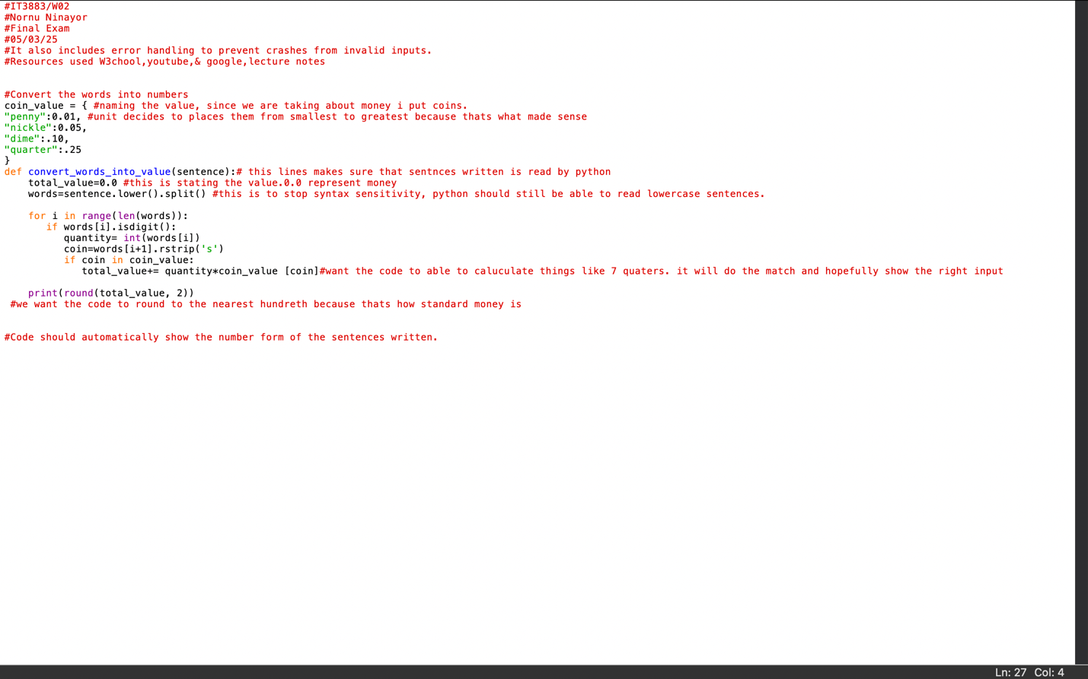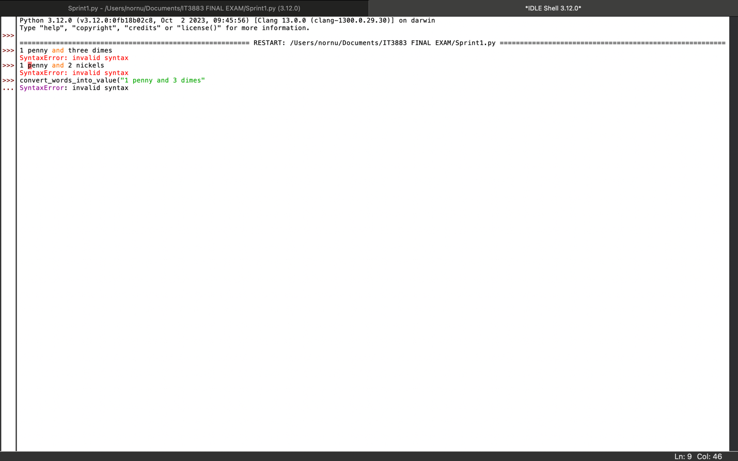

I was getting constant error code because my syntax was wrong. There were so many grammatical errors and wrong indentations. Every time I would run the code it wouldn’t work.

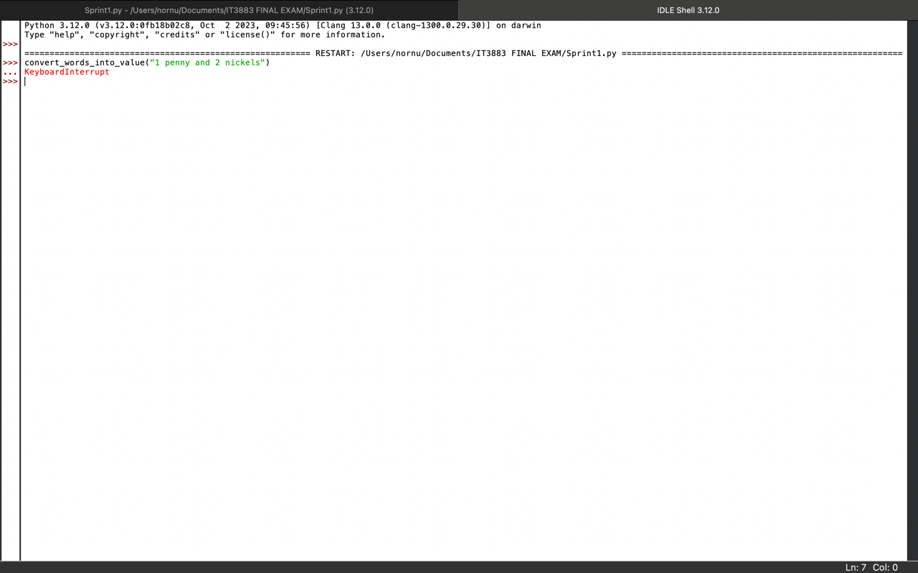

I finally tweaked it a little bit but didn’t understand why the output wouldn’t show. I realize that to properly see this code the user must first type out convert_words_into_value. This is a must for the code to function. Without it this code will not work

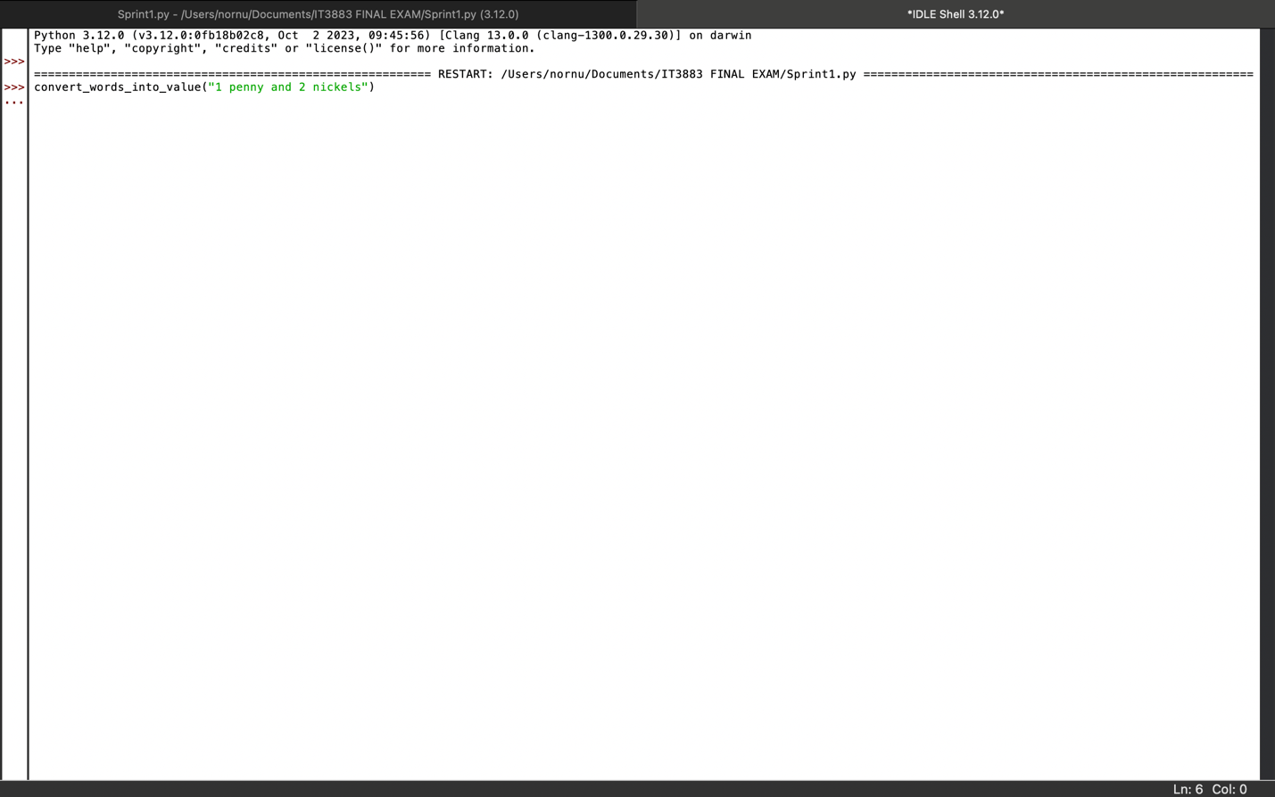

Testing:
The following shows the test I ran inserting the inputing and expexting the output given in the document.

Input | Expected outcome | Actual outcome | Pass/Fail

1 penny and 2 nickels | 0.11 | 0.01 | Fail
4 dimes and 7 quarters | 2.15 | 2.15 | pass
1 quarter and 3 pennies | .28 | .25 | Fail
21 pennies and 17 dimes and 52 quarters | 14.91 | 14.70 | Fail
1 nickel and 17 quarters | 4.30 | 4.25 | Fail
21 nickels and 15 pennies | 1.20 | 0.00 | fail
95 dimes and 73 quarters and 22 nickels and 36 pennies | 29.21 | 27.75 | fail
1 dime and 1 nickel and 1 penny and 1 quarter | .41 | .36 | fail

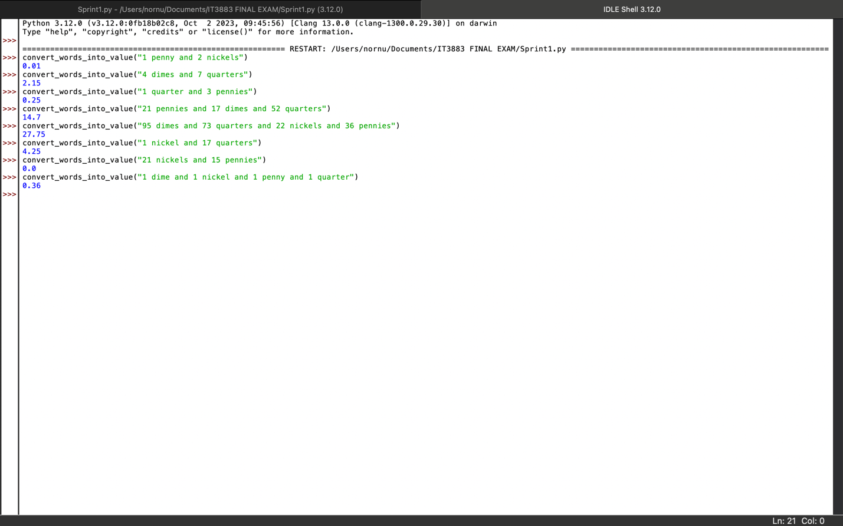

Only one input pass. The number were all off. The code was not accounting for the plural and singular form of the words.

Sprint 2:
Updated code:

Start

#Convert the words into numbers
coin_value = { #naming the value, since we are taking about money i put coins.
"pennies":0.01, #unit decides to places them from smallest to greatest because thats what made sense
"nickels":0.05, #was spelling nickels wrongs,giving me the wrong output
"dimes":.10,
"quarters":.25
}
def convert_words_into_value(sentence):# this lines makes sure that sentences written is read by python
total_value=0.0 #this is stating the value.0.0 represent money
words=sentence.lower().split() #this is to stop syntax sensitivity, python should still be able to read lowercase sentences.

for i in range(len(words)):
if words[i].isdigit():
quantity= int(words[i])
coin=words[i+1]

if coin=="penny":
coin="pennies" #so this will account for singular and plural inputs that are given.
elif coin=="nickel":
coin="nickels"
elif coin=="dime":
coin="dimes"
elif coin=="quarter":
coin="quarters"

if coin in coin_value:
total_value+= quantity*coin_value [coin]#want the code to able to calculate things like 7 quarters. it will do the match and hopefully show the right input

print(round(total_value, 2))
#we want the code to round to the nearest hundredth because that’s how standard money is

#Code should automatically show the number form of the sentences written.

End

Testing:

Input | Expected outcome | Actual outcome | Pass/fail

1 penny and 2 nickels | 0.11 | .11 | Pass
4 dimes and 7 quarters | 2.15 | 2.15 | Pass
1 quarter and 3 pennies | 0.28 | 0.28 | Pass
21 pennies and 17 dimes and 52 quarters | 14.91 | 14.91 | Pass
95 dimes and 73 quarters and 22 nickels and 36 pennies | 29.21 | 29.21 | Pass
1 nickel and 17 quarters | 4.30 | 4.30 | Pass
21 nickels and 15 pennies | 1.20 | 1.20 | Pass
1 dime and 1 nickel and 1 penny and 1 quarter | .41 | .41 | Pass

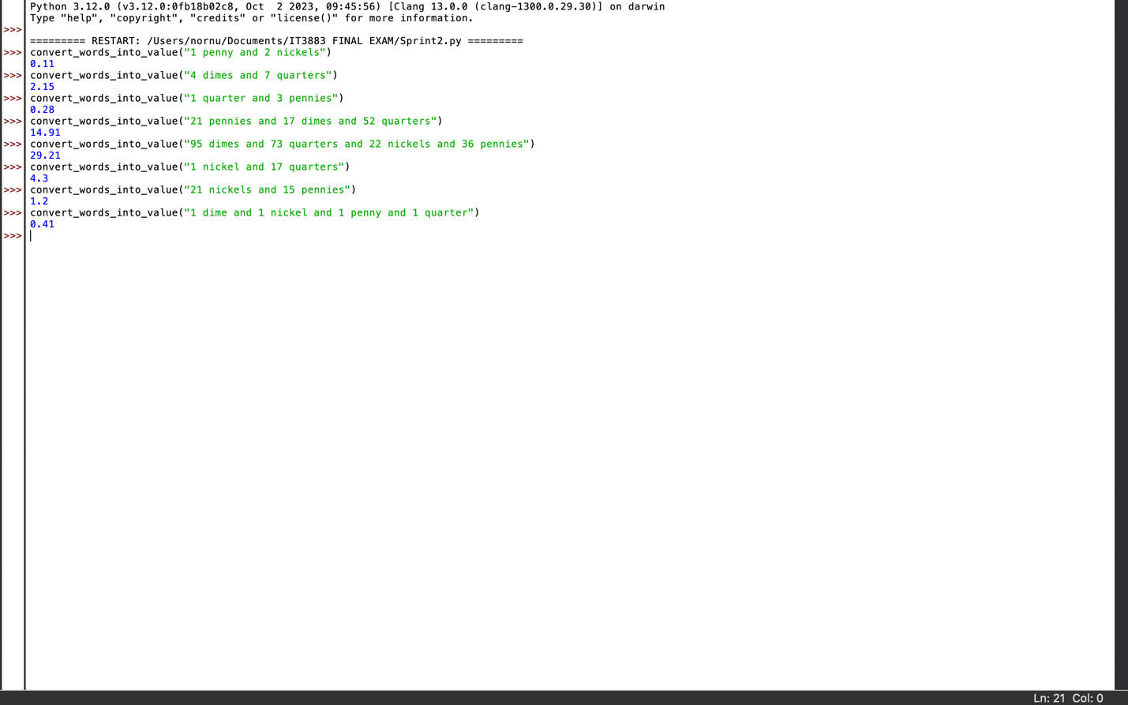

Summary: for this code to work completely users will have to first use convert_words_into_value. There weren’t too many bugs in this version. I don’t know why out instead of a zero being placed at the end it just and empty space.

